Exp1:-
Title of the program:-
A circle has center coordinate (3,2) & radius is 5 unit. Take a point (h,k) on the coordinate system. Write a program to check whether the point is on the circle or inside or outside the circle.
Program instruction:-
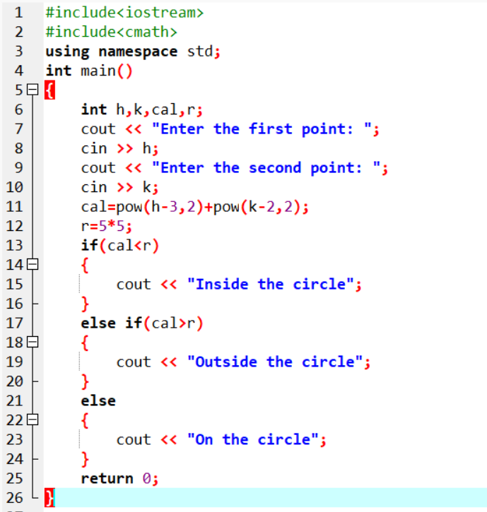
Output:-

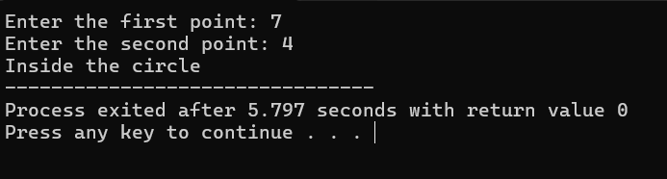

Exp2:-
Title of the program:-
Given an array of numbers {3,5,7,9,5,11,7,13,11} write the program to compute the number of repetitions of each number in the series.
Program instruction:-

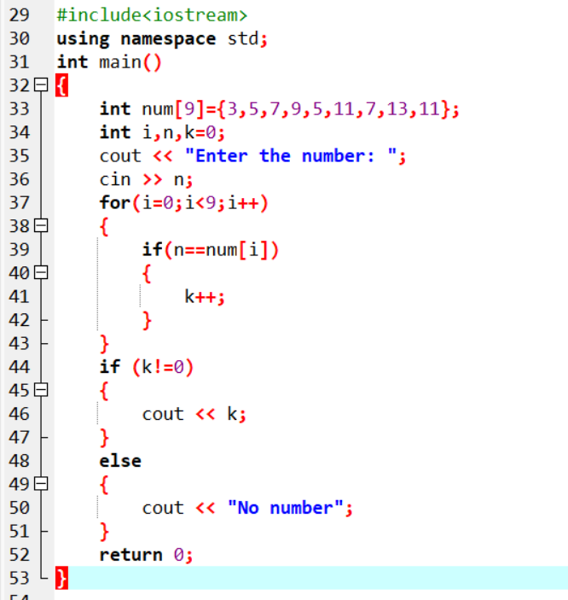

Output:-

